_______________________________________________________________
16S Microbiome QIIME2 Analysis
_______________________________________________________________
Abrar Al-Shaer
Raz Shaikh Lab
12/10/2018

- Introduction – QIIME 2.6 Paired End Analysis (github.com/abrar-alshaer/QIIME2_16S-Analysis)
This manual is adapted from the QIIME2.6 “Moving Pictures” Tutorial
(https://docs.qiime2.org/2018.6/tutorials/moving-pictures/)

16S data files often include many fastq files filled with genomic sequences and their corresponding fastqc, or quality scores. This pipeline discusses how to generate counts for 16S sequence variants from raw fastq sequence files and any important notes taken from my analysis when running the procedure.

*IMPORTANT NOTE*
- This protocol assumes that primer/adapter sequences have already been TRIMMED and all files are DEMULTIPLEXED. You can check for this in the FASTQC software.
The FastQC manual can be found here (https://biof-edu.colorado.edu/videos/dowell-short-read-class/day-4/fastqc-manual), where it explains in depth how to understand the results of a fastqc report. You can download the fastqc software here:
http://www.bioinformatics.babraham.ac.uk/projects/fastqc/
- FastQC with Java JRE information
(Documentation: http://www.bioinformatics.babraham.ac.uk/projects/fastqc/INSTALL.txt)
Make sure to check the FastQC documentation information above in order to install the correct version of Java on your computer that will run FastQC without any issues.

- Goal (Expected Result)
The expected results from this analysis are the generation of sequence variant count files for each taxonomic level (phylum through species). Each fastq input file represents one sample, unless you are working with paired end sequences. Paired end sequences include forward and reverse strands from the 16S sequencing technologies. Paired end sequence files are almost always clearly identified by their file name – either ending in R1 or R2 – corresponding to forward and reverse respectively. When analyzing paired end files, it is important to run them concurrently in the analysis. At the end of the analysis each taxonomic file should result in a column of microbial sequence variants with corresponding counts for each sample.
- Methodology & Tools

  - Installing Packages/Cluster Module Imports
When running this analysis you can either install all the tools to your own personal desktop or you can run the analysis from a remote server at a high power computer cluster. The latter is preferred since many of these steps require high amounts of RAM, even with a 32Gb RAM desktop it can take a long time to run the analysis depending on the number of samples. The tools used for this analysis are:
- QIIME2
- BiomFormat package
- DESeq2 R software
- Phyloseq R package
*These tools have many dependencies, make sure to install all co-dependent software.
If you are using a computing cluster, then there is no need to install the packages above (except for biom format) – you simply must load them as modules. However, you first must make sure the packages exist as modules on the computing cluster. I will be using the Longleaf (big RAM) cluster at UNC as an example for the commands below:
- To see the full list of the applications in the computer cluster run: module avail
- The /ms directory is for mass storage – do not run programs on here.
- To run commands and programs cd into [/pine/scr/o/n/onyen/] with your onyen information.
  - This directory (/pine/scr/o/n/onyen/) will only hold your files for 36 days then they will be deleted, so make sure to transfer everything to the ms directory after running a program.
- To load modules for this analysis run the module load command: module load qiime2
- More information about Longleaf cluster: http://help.unc.edu/help/getting-started-example-slurm-on-longleaf/

  - Formatting Data Files
The file name includes the sample identifier and should look like L2S357_15_L001_R1_001.fastq.gz. The underscore-separated fields in this file name are:
- the sample identifier,
- the barcode sequence or a barcode identifier,
- the lane number,
- the direction of the read (i.e. only R1, because these are single-end reads), and
- the set number will always equal 001.
For example:
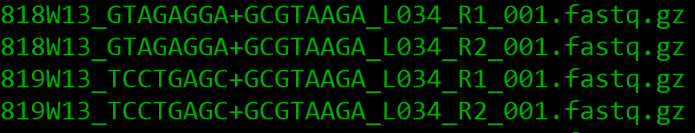
      - Files don’t have to contain the barcode sequence – optional.
To rename the middle of a file for all files in a directory:
for i in *.fastq.gz; do mv $i $(echo $i | sed 's/_0034/_001/g'); done
You must make a manifest file to import your data into QIIME2 with the following format:
sample-id,absolute-filepath,direction
# Lines starting with '#' are ignored and can be used to create
# "comments" or even "comment out" entries
sample-1,$PWD/some/filepath/sample1_R1.fastq.gz,forward
sample-2,$PWD/some/filepath/sample2_R1.fastq.gz,forward
sample-1,$PWD/some/filepath/sample1_R2.fastq.gz,reverse
sample-2,$PWD/some/filepath/sample2_R2.fastq.gz,reverse
To get all file paths for the Manifest file:
ls -d "$PWD"/* > listOfFiles.txt
  - Importing Data Files into a QIIME2 Artifact
    - Command for importing Data:
qiime tools import --type 'SampleData[PairedEndSequencesWithQuality]' --input-path /pine/scr/a/b/abrar/ALL_RUNS/Week13-14/manifest.csv --output-path W13_14_demux-paired-end.qza --source-format PairedEndFastqManifestPhred33
    - More info about data import: https://docs.qiime2.org/2018.6/tutorials/importing/
  - Trimming bad sequences with low quality scores using DADA2
DADA2 is a pipeline for detecting and correcting (where possible) Illumina amplicon sequence data. As implemented in the q2-dada2 plugin, this quality control process will additionally filter any phiX reads (commonly present in marker gene Illumina sequence data) that are identified in the sequencing data and will filter chimeric sequences.
The dada2 denoise-single method requires two parameters that are used in quality filtering: --p-trim-left m, which trims off the first m bases of each sequence, and --p-trunc-len n which truncates each sequence at position n.
    - Commands for running DADA2 on QIIME2:
(You must submit a cluster batch job for this step because it can take up to 2 days to run)
Single End Run:
sbatch --time=24:00:00 --mem-per-cpu=80000 -n 2 -o qiimeDADA2.out --wrap="qiime dada2 denoise-single --i-demultiplexed-seqs W13_14_demux-paired-end.qza --p-trunc-len 0 --o-representative-sequences rep-seqs-dada2.qza --o-table table-dada2.qza --o-denoising-stats stats-dada2.qza"

Paired End Run:
sbatch --time=48:00:00 --mem-per-cpu=100000 -n 2 -o qiimeDADA2_abrar.out --wrap="qiime dada2 denoise-paired --i-demultiplexed-seqs W13_14_demux-paired-end.qza --p-trunc-len-f 0 --p-trunc-len-r 0 --o-representative-sequences rep-seqs-dada2.qza --o-table table-dada2.qza --o-denoising-stats stats-dada2.qza"

*In this example I don’t want to trim anything because the sequencing facility already trimmed all my sequences and removed low quality sequence reads and filtered chimeras.

However, if the sequencing facility did not do this for you, do the following:
      - Open the demux.qzv file in QIIME2 View
      - Click on Interactive Quality Plot on the top of the page.
      - You will see a plot like this:
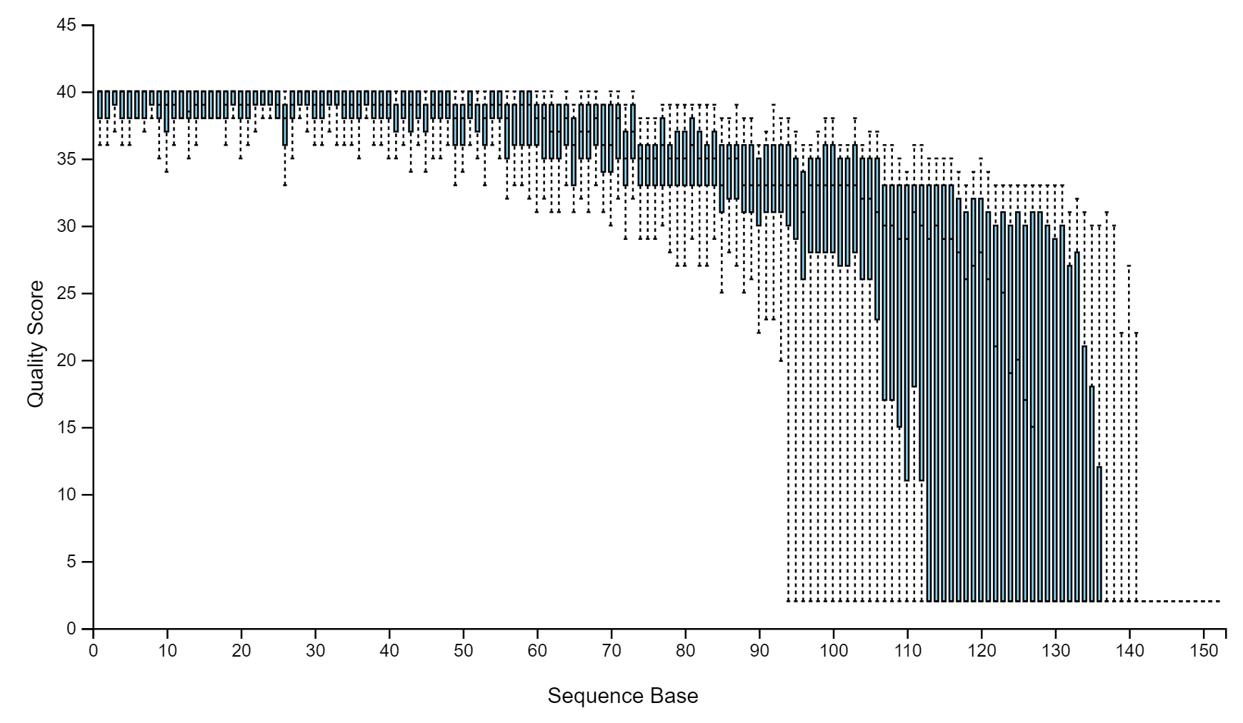
      - The plot above shows the quality scores at all the base pair locations for all your sequences. You need to choose a cut off value for where to discard low quality sequences. Usually the accepted cut off is anything below 35 or 30.
For example, the cut off for the above plot would be ~ 120:
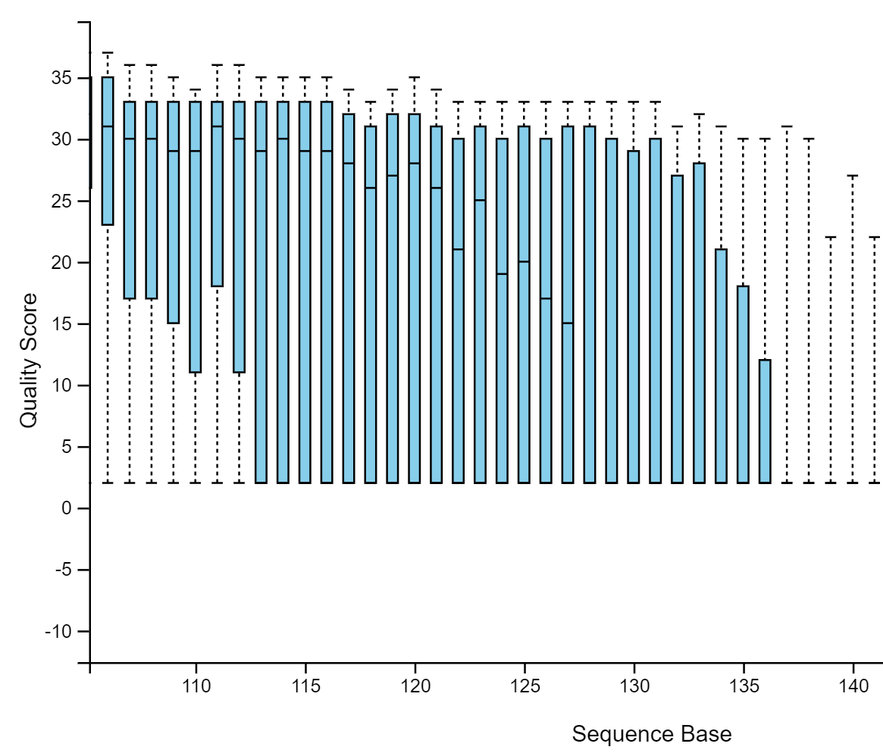
You can also specify a cut off to trim from the beginning if your sequences start off with low quality, increase, then drop off again. An example command of trimming paired end sequences at particular base pair locations is shown below:

sbatch --time=48:00:00 --mem-per-cpu=100000 -n 2 -o qiimeDADA2_12.5.18.out --wrap="qiime dada2 denoise-paired --i-
demultiplexed-seqs paired-end-demux.qza --p-trim-left-f 28 --p-trunc-len-f 236 --p-trim-left-r 0 --p-trunc-len-r 185 --o-representative-sequences
rep-seqs-dada2.qza --o-table table-dada2.qza --o-denoising-stats stats-dada2.qza"

Documentation for all the parameters in the dada2 paired end sequences command:
https://docs.qiime2.org/2018.2/plugins/available/dada2/denoise-paired/

  - Generate a tree for phylogenetic diversity analyses

    - QIIME supports several phylogenetic diversity metrics, including Faith’s Phylogenetic Diversity and weighted and unweighted UniFrac. These metrics require a rooted & unrooted phylogenetic tree relating the features to one another. The following steps will generate these QIIME 2 artifacts.
    - Commands for running phylogeny:
qiime alignment mafft --i-sequences rep-seqs-dada2.qza --o-alignment aligned-rep-seqs.qza
qiime alignment mask --i-alignment aligned-rep-seqs.qza --o-masked-alignment masked-aligned-rep-seqs.qza
qiime phylogeny fasttree --i-alignment masked-aligned-rep-seqs.qza --o-tree unrooted-tree.qza
qiime phylogeny midpoint-root --i-tree unrooted-tree.qza --o-rooted-tree rooted-tree.qza

  - Taxonomic Classification
    - Make sure to create a metadata file like in the example below:

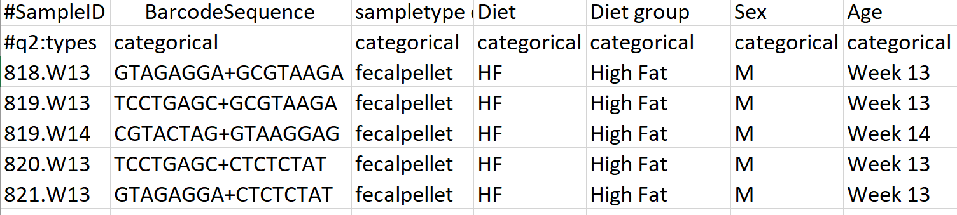

    - Training the16S classifier (Naïve Bayes classification):
*I am using the SILVA database classifier because it is the most recently updated one and contains more sequences (greengenes was updated in 2013)
https://docs.qiime2.org/2018.6/data-resources/ link to download differently trained classifiers
https://docs.qiime2.org/2018.6/tutorials/feature-classifier/ link explaining how to train your own classifier with scikit learn Naïve Bayes algorithm
      - Command for running the trained classifier:
Full SILVA database classifier:
qiime feature-classifier classify-sklearn --i-classifier silva-132-99-nb-classifier.qza --i-reads rep-seqs-dada2.qza --o-classification taxonomy.qza

  - Generating Emperor PCoA Plots & Calculating Alpha/Beta Diversities
    - Commands for making PCoA Plots from feature tables:
      - qiime feature-table summarize --i-table table-dada2.qza --o-visualization table.qzv --m-sample-metadata-file metadata_W13-14_10.23.18.txt
      - qiime feature-table tabulate-seqs --i-data rep-seqs-dada2.qza --o-visualization rep-seqs.qzv
      - qiime diversity core-metrics-phylogenetic --i-phylogeny rooted-tree.qza --i-table table-dada2.qza --p-sampling-depth 14841 --m-metadata-file metadata_W13-14_10.23.18.txt --output-dir core-metrics-results

*The number 14841 is custom based on the table.qzv output – look at frequency counts of the sample file (under “Frequency per sample”) and choose a number not too high and not too low. This step is called rarefaction and has much controversy in the field. Rarefaction should only be used when assessing species richness (i.e. alpha/beta diversity) and never as a normalization technique. Sort your table from smallest to largest then choose somewhere around the second smallest number, or where your variation in sequence counts begins to decrease.

Example: (1109 was chosen in this dataset)
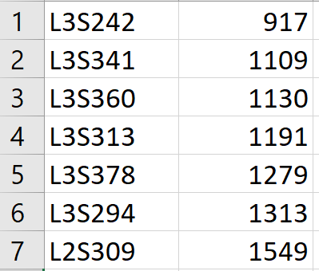
    - Commands for calculating alpha & beta diversity metrics:
Alpha Diversity:
qiime diversity alpha-group-significance --i-alpha-diversity core-metrics-results/faith_pd_vector.qza --m-metadata-file metadata_W13-14_10.23.18.txt --o-visualization core-metrics-results/faith-pd-group-significance.qzv
qiime diversity alpha-group-significance --i-alpha-diversity core-metrics-results/evenness_vector.qza --m-metadata-file metadata_W13-14_10.23.18.txt --o-visualization core-metrics-results/evenness-group-significance.qzv

Beta Diversity:
qiime diversity beta-group-significance --i-distance-matrix core-metrics-results/unweighted_unifrac_distance_matrix.qza --m-metadata-file metadata_W13-14_10.23.18.txt --m-metadata-column Diet --o-visualization core-metrics-results/unweighted-unifrac- significance.qzv --p-pairwise
qiime diversity beta-group-significance --i-distance-matrix core-metrics-results/unweighted_unifrac_distance_matrix.qza --m-metadata-file metadata_W13-14_10.23.18.txt --m-metadata-column Diet --o-visualization core-metrics-results/unweighted-unifrac -significance.qzv --p-pairwise

The core-metrics-results directory contains all the alpha/beta diversity results & generated Emperor plots.

  - How to Interpret Alpha & Beta Diversity?
    - Alpha diversity
      - Shannon’s diversity index (a quantitative measure of community richness)
      - Observed OTUs (a qualitative measure of community richness)
      - Faith’s Phylogenetic Diversity (a qualitiative measure of community richness that incorporates phylogenetic relationships between the features)
      - Evenness (or Pielou’s Evenness; a measure of community evenness)
        - You can get the raw Pielou numbers to make the diversity plot yourself by downloading the raw data TSV file in qiime2 view when you view the evenness qzv file.
    - Beta diversity (all the plots below are different beta diversity metrics)
      - Jaccard distance (a qualitative measure of community dissimilarity)
      - Bray-Curtis distance (a quantitative measure of community dissimilarity)
      - unweighted UniFrac distance (a qualitative measure of community dissimilarity that incorporates phylogenetic relationships between the features)
      - weighted UniFrac distance (a quantitative measure of community dissimilarity that incorporates phylogenetic relationships between the features)
  - Generating Relative Frequency Plots & Obtaining Raw Sequence Counts
    - qiime taxa barplot --i-table table-dada2.qza --i-taxonomy taxonomy.qza --m-metadata-file metadata_W13-14_10.23.18.txt --o-visualization taxa-bar-plots.qzv
    - Take the taxa-bar-plots.qzv output and place it into QIIME2 View to see the plots with relative frequencies/abundances. From there you can download the CSV files for each taxonomy level that contains all the raw abundance counts.
  - Commands to summarize counts by taxonomy:
    - qiime taxa collapse --i-table table-dada2.qza --i-taxonomy taxonomy.qza --p-level 2 --o-collapsed-table table_phylum.qza
    - qiime taxa collapse --i-table table-dada2.qza --i-taxonomy taxonomy.qza --p-level 3 --o-collapsed-table table_class.qza
    - qiime taxa collapse --i-table table-dada2.qza --i-taxonomy taxonomy.qza --p-level 4 --o-collapsed-table table_order.qza
    - qiime taxa collapse --i-table table-dada2.qza --i-taxonomy taxonomy.qza --p-level 5 --o-collapsed-table table_family.qza
    - qiime taxa collapse --i-table table-dada2.qza --i-taxonomy taxonomy.qza --p-level 6 --o-collapsed-table table_genus.qza
    - qiime taxa collapse --i-table table-dada2.qza --i-taxonomy taxonomy.qza --p-level 7 --o-collapsed-table table_species.qza

Another method to get the raw abundance counts:
After getting the individual taxonomy tables, you need to convert the .qza files to a readable format for counts. First run this:

mv table.qza table.zip
- Now unzip the file like usual
- Inside the data folder in the unzipped file you will find a BIOM table – however it contains gibberish if not converted to a text file.
- Install biom-format then run this command:
biom convert -i feature-table.biom -o table.from_biom.txt --to-tsv
Now you have the counts!

- Normalization & Statistical Analyses
Now you have abundance count tables, as CSV or TSV files. If you have the tables as TSV files convert them to CSV format. The next step is to normalize your abundance counts with either CSS, DESeq2, or metagenomeSeq. In this example we will use DESeq2 in R:

Normalization Methods (Paper: Waste Not, Want Not: Why Rarefying Microbiome Data Is Inadmissible):
- DESeq2 - nbinomWaldTest. A Negative Binomial Wald Test using standard maximum likelihood estimates for GLM coefficients assuming a zero-mean normal prior distribution, implemented in the nbinomWaldTest method of the DESeq2 package.
- metagenomeSeq - fitZig. An Expectation-Maximization estimate of the posterior probabilities of differential abundance based on a Zero Inflated Gaussian model, implemented in the fitZig method of the metagenomeSeq package
  - Before inputting the abundance counts CSV file into the normalization script, you must filter any taxa that are zero-inflated by 25% (more than 25% of the samples contain zero counts). It may also be helpful to remove all the prefixes for each taxon and cut it down to only the microbe’s name. For example: D_0__Bacteria;D_1__Firmicutes;D_2__Clostridia;D_3__Clostridiales = “Clostridiales”

  - To normalize the data you must make a phyloseq data object from the counts data and import that into the DESeq2 package for normalization. To import the data into phyloseq in R (using the DESeq2_phyloSeq.R script) make sure that your counts data for all the taxonomic levels is combined into one massive CSV file formatted like this:

Combo_Sequence_Abundances.csv example file:
samples
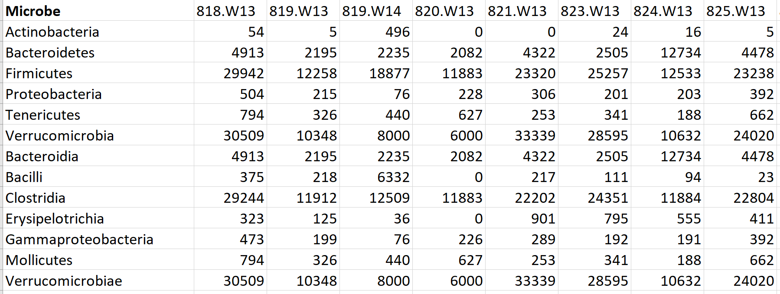

  - You must also create a taxa.csv file that contains all the taxonomic levels for each microbe in your combo sequence abundances file.

Taxa.csv example file:

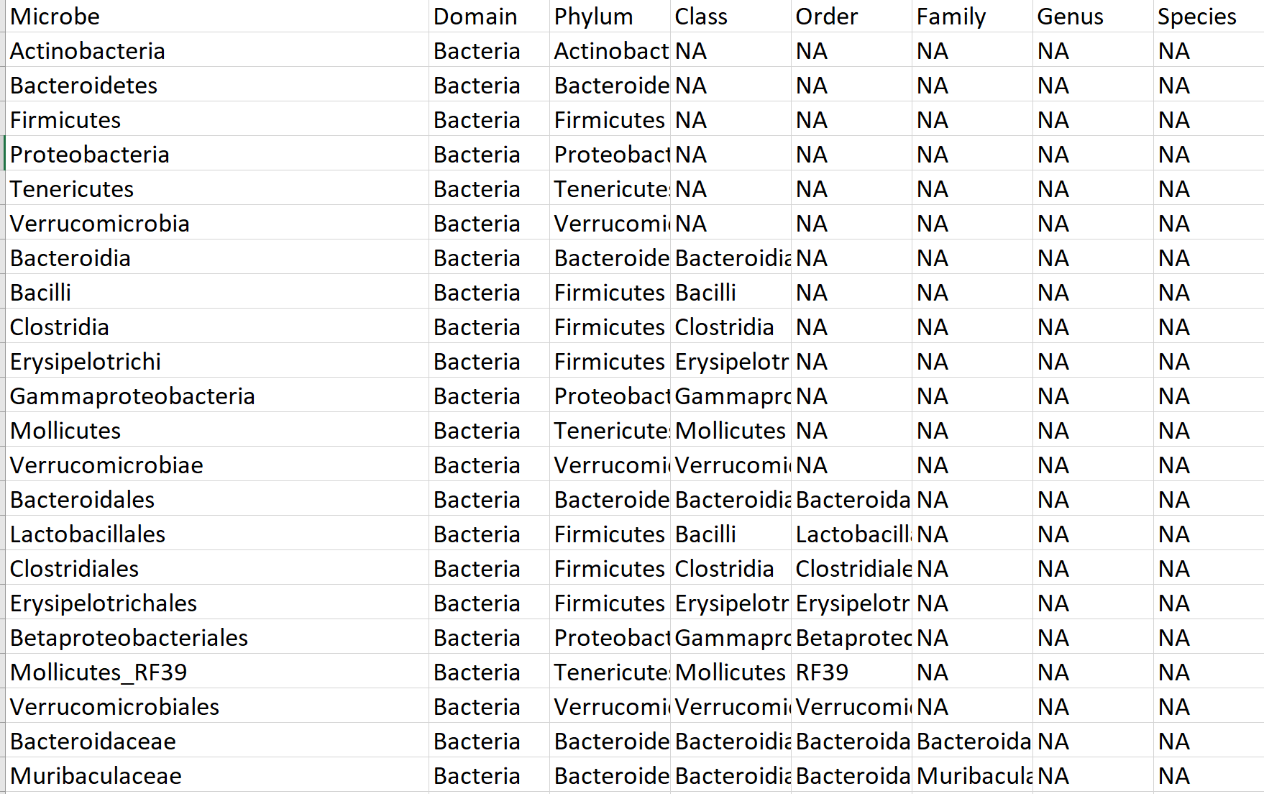

  - When running the DESeq2_phyloSeq.R script you will generate NMDS and PCoA plots (for more info on ordination methods with phyloseq: https://joey711.github.io/phyloseq/plot_ordination-examples.html#mds_(%E2%80%9Cpcoa%E2%80%9D)_on_unifrac_distances). Using normalized or non-normalized results to generate the NMDS plot makes no difference in the graphing because NMDS is a non-parametric method that relies on ranks.
  - If your data is non-linear and likely to be non-parametric, then using NMDS would give you better and more correct clustering results. A good video explaining NMDS: https://www.youtube.com/watch?v=Kl49qI3XJKY

  - For the step: phylo <- subset_samples(phylo, Diet != "C") we are removing the control samples because we want to see differences between HF+EPA & HF. You must subset your datasets to 2 categories that you want to test differences between because DESeq’s statistical analyses and fold change calculations rely on the assumption that you are comparing 2 groups to each other and no more. After running the DESeq2 analysis you will get a result like this:
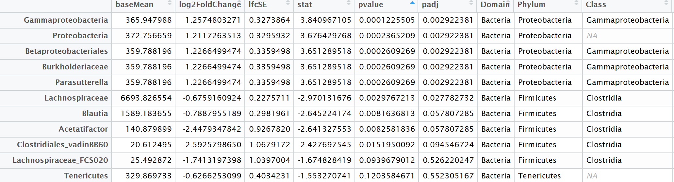
*For explanations on what the column headers mean, reference the DESeq2 R manual.
IMPORTANT: You must find out if the fold change difference outputted from DESeq2 is HF vs HF+EPA or HF+EPA vs HF. Meaning did it use the correct group to compare as a baseline. In our case we want to make sure that HF was the baseline group to compare from. To figure out which group was used for baseline in the analysis, look at the res object (type res in the console) – and it will tell you what it used for the fold change. For example: “log2 fold change (MLE): Diet HF_EPA vs HF”. In this example, it used HF as a correct baseline, since DESeq2 writes the baseline group second, and it’s comparing the EPA versus the HF. You an also check if the fold changes (FC) are correct when comparing the FC direction (+/-) with the trends from the boxplot output (below).
  - The DESeq2_phyloSeq.R script will also generate a normalized count table when you run the command: counts <- counts(diagdds, normalized=TRUE).
  - Next, use the normalized counts table that you got (output that table as a CSV file) to generate Log10 normalized boxplots for each microbe. The script for generating these boxplots from the normalized counts is called QIIME2_analysis.R
    - In this script the assumption of normality is checked to decide whether to use a parametric or non-parametric test for the statistical analysis. Example output (right):
- Additional Resources
  - Additional scripts include:
    - Cage effects analysis script & outlier script: cage_effects.R & 16S_outlier_analysis.R
    - DADA2.R analysis script if you are unable to run QIIME2 on a linux server.
    - A 16S_microbiome_analysis.R script & OTU_plots.R script for analyzing output from BioLockJ’s QIIME1.9 pipeline.

